Abhishek Garg

Econ 155 – Lawrence Goulder

March 3, 2014

Oil Development in the Amazon

The Amazon rainforest is one of the most biodiverse but also one of the most oil rich places in the world. These two characteristics make the policy decisions regarding the forest a dilemma between the temptation of energy resources and the desire to protect the environment. Currently, Ecuador, a small country in South America is faced with this dilemma. The issue is over the Yasuni ITT- a stretch of Amazon rainforest within the Yasuni National Park in Ecuador with vast oil reserves consisting of 20% of the proven reserves of the country underneath a microcosm of indigenous life and a precious natural ecosystem (Warnars 60).

This past summer, the president of Ecuador, Raphael Correra, decided to allow for oil drilling in the Yasuni National Park after a failed initiative to ask foreign nations to pay Ecuador not to drill here. We will evaluate this decision on two criteria. First, we will look at what are the benefits of drilling here verses the status quo of not drilling. Then secondly we will analyze the distributional effects of this decision as in which parties will be the winners and losers and whether this distribution ethically justifiable.

This issue is critically important for three reasons. First, it will set a precedent for other environmental decisions in Ecuador and the rest of Latin America. Second, the Yasuni is a biological hotspot and has several thousand species endemic to this park. The oil development will affect the health of this ecosystem in ways discussed later. Third, the Yasuni is home to indigenous peoples who vehemently oppose oil drilling here. Ecuador has had a sad history of environmental devastation due to oil spills in the past few decades that has made indigenous people very bitter of oil drilling. Pushing forward for oil development despite indigenous opposition raises moral issues that must be considered.

It has been estimated that there are 900 million barrels of oil in the Yasuni ITT. PetroEcuador, Ecuador’s state owned oil company has calculated the profit from extracting this oil and estimated it to be $14.36 billion (Warnars 63). For our analysis, we can assume that this would provide a benefit of $15.95 per 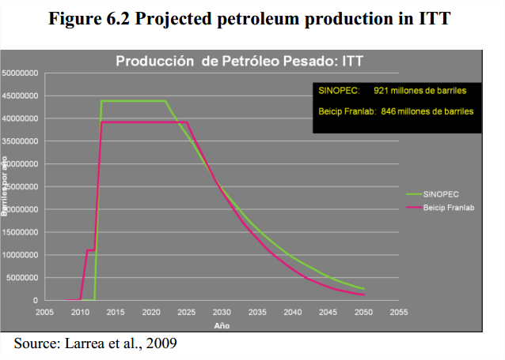barrel of oil drilled to the government of Ecuador which owns PetroEcuador.

On the cost side, we have already included capital and variable costs in getting the $15.95 per barrel figure. Other costs incurred are environmental externalities. Indigenous tribes do not have significant amount of money so they lose no surplus as a result of any damages to the environment. If we try to apply real or stated preferences to see how much these indigenous people value their environment, we would get zero because since they have no money, they have no willingness and ability to pay to avoid damages to their environment. Therefore, there would not be an externality resulting from harm to the way of life of indigenous tribes.

There would however, be other environmental externalities associated with damages to the environment. One of these externalities is CO2 emissions associated with refining and consuming the oil. For the 900 million barrels of oil in the Yasuni, this is estimated to release 407 million metric tones of CO2 into the atmosphere (Warnars 63). Estimates we have used in class price the externality of a ton of CO2 to be $30 (get citation). Therefore, the externality associated with the oil in the Yasuni would be 407 million tons \* $30 per ton / 900 million barrels which is $13.56 per barrel.

Increases in carbon in the atmosphere will spread evenly across the globe. Ecuador, being a small country, will therefore be only marginally impacted by the increases in atmospheric carbon associated with drilling in the Yasuni. However, environmental damages will result from drilling in the Amazon that has externalities for Ecuador. A large part of this externality is because people of Ecuador strongly value the flourishing biodiversity of the rainforest. This value is evident through massive outrage at Chevron which was sued in 2011 for oil spills by Texaco – an oil company Chevron bought. Drilling in the Amazon would incur damages to the environment in the form of habitat destruction due to installation of infrastructure necessary for drilling and due to leaks in pipelines transporting this oil. Petroecuador, the company drilling this oil has a particularly egregious track record in drilling this oil. Petroecuador has had a world record of 400 leaks per year on average and is known to dump “liquid garbage,” byproducts of oil drilling into lakes and streams in the Amazon (Warnar 54).

We can use data from the Yasuni ITT initiative as a proxy for how much Ecuador and the rest of the world values these externalities. Under the Yasuni ITT initiative, Ecuador announced it would not drill in the Yasuni ITT if the international community provided Ecuador half of expected profits or $7.18 over ten years as compensation. This means that if Ecuador values lost environmental benefits from drilling in the Yasuni to be half of the expected profits or $7.18 billion (Finer, Monsen, Jensen 63). This is because Ecuador can get $14.36 billion for drilling but will choose not to drill if it gets paid $7.18 billion not to. So Ecuador values environmental costs of drilling at $7.18 billion. Foreign governments pledged $113 million to the Yasuni ITT initiative, and we can use this as a proxy for how much their existence value for the Yasuni is. The total exernality is then $7.18 billion for Ecuador plus $113 million for the rest of the world, to get $7.29 billion. With 900 million barrels of oil, this is an externality of $8.10 per barrel.

Therefore, in terms of overall efficiency, it would not be efficient for Ecuador to drill for any oil in the Yasuni ITT. Doing so has a profit of $15.95 per barrel but has an externality of $13.56 per barrel associated with increased CO2 emissions and an externality of $8.10 per barrel due to environmental destruction. Therefore the benefits ($15.95 per barrel) are outweighed by the cost ($21.66 per barrel), and Ecuador should not drill from an efficiency point of view.

A caveat is however that if Ecuador acts from a completely selfish point of view and does not care about the externality of CO2 increases for the rest of the world, it would be efficient for Ecuador to extract the oil in the Yasuni as the profit per barrel at $15.95 would be higher than the domestic externality at $7.97 per barrel. However this calculation is for efficiency for Ecuador as a single entity. There would be important distributional impacts of parties within Ecuador.